
DA Software Solutions (Pvt.) Limited.
#76, Pagoda Road, Nugegoda. Sri Lanka.
E-mail: dumindu@dassonline.com
Phone: +94 114 941 921, +94 773 435 429

Client Name/Address
Date : 27th July 2011
Our Reference : DASS /INV
Invoice Number : TI 269

Mr.Imdad Nagub,
Manager IT,
Citizen Development Bank

INVOICE
Description
Pawn - Brokering Management” Software Solution

Particulars | Amount (LKR)
Cost of “Pawn - Brokering Management” Software Solution  Special Discount | 650,000.00  (50,000.00)
Sub Total  50% on confirmation of the quotation paid by CDB  30% on Live Run of the Software Solution paid by CDB  Part payment of UAT paid by CDB | 300,000.00  180,000.00  70,000.00
Invoice Balance implementation cost | 50,000.00

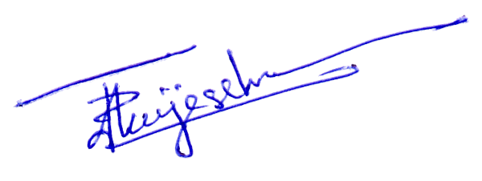
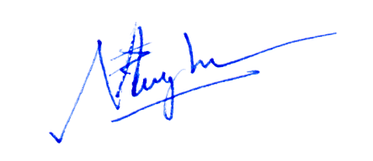

Prepared by: ………………………………. Authorized by: ……………………..................

